Supplementary Materials: Figures and Tables

- Anatomy, Introduction, Mechanism related images and formulation of an ideal emulgel-

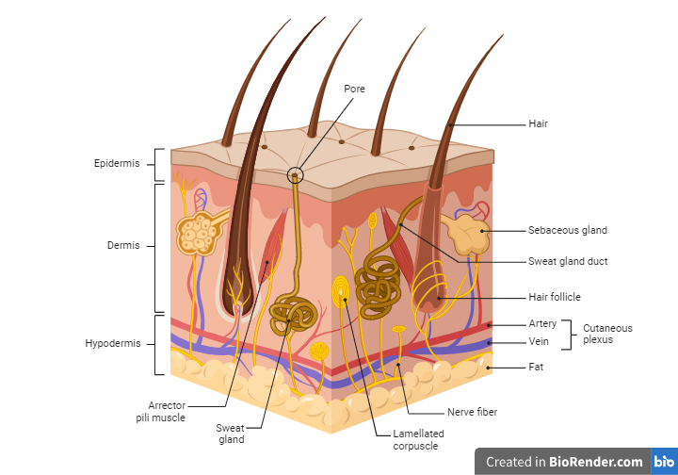
Figure S1: Anatomy of hair (https://www.biorender.com/)

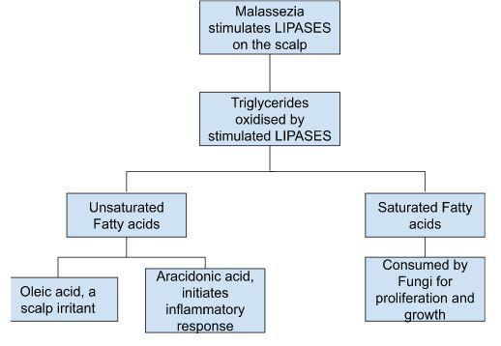

Fig S2: Dandruff caused due to lipases ^{[1]}

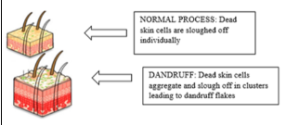
Fig S3: Flakiness of hair scalp ^{[2]}

- Emulgel is formed by following procedure: ^{[3]}
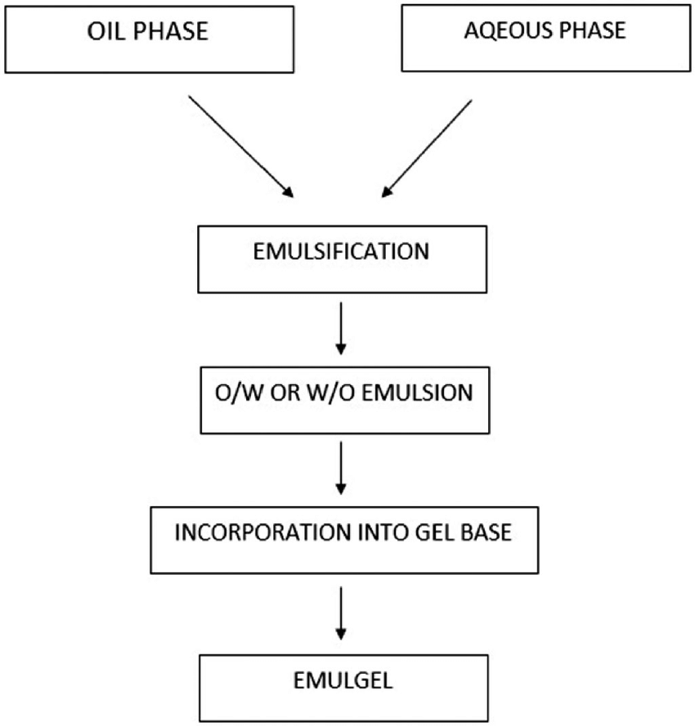

Fig S4: Formulation of an Ideal Emulgel

- Characterization of Malessezia species using gram staining

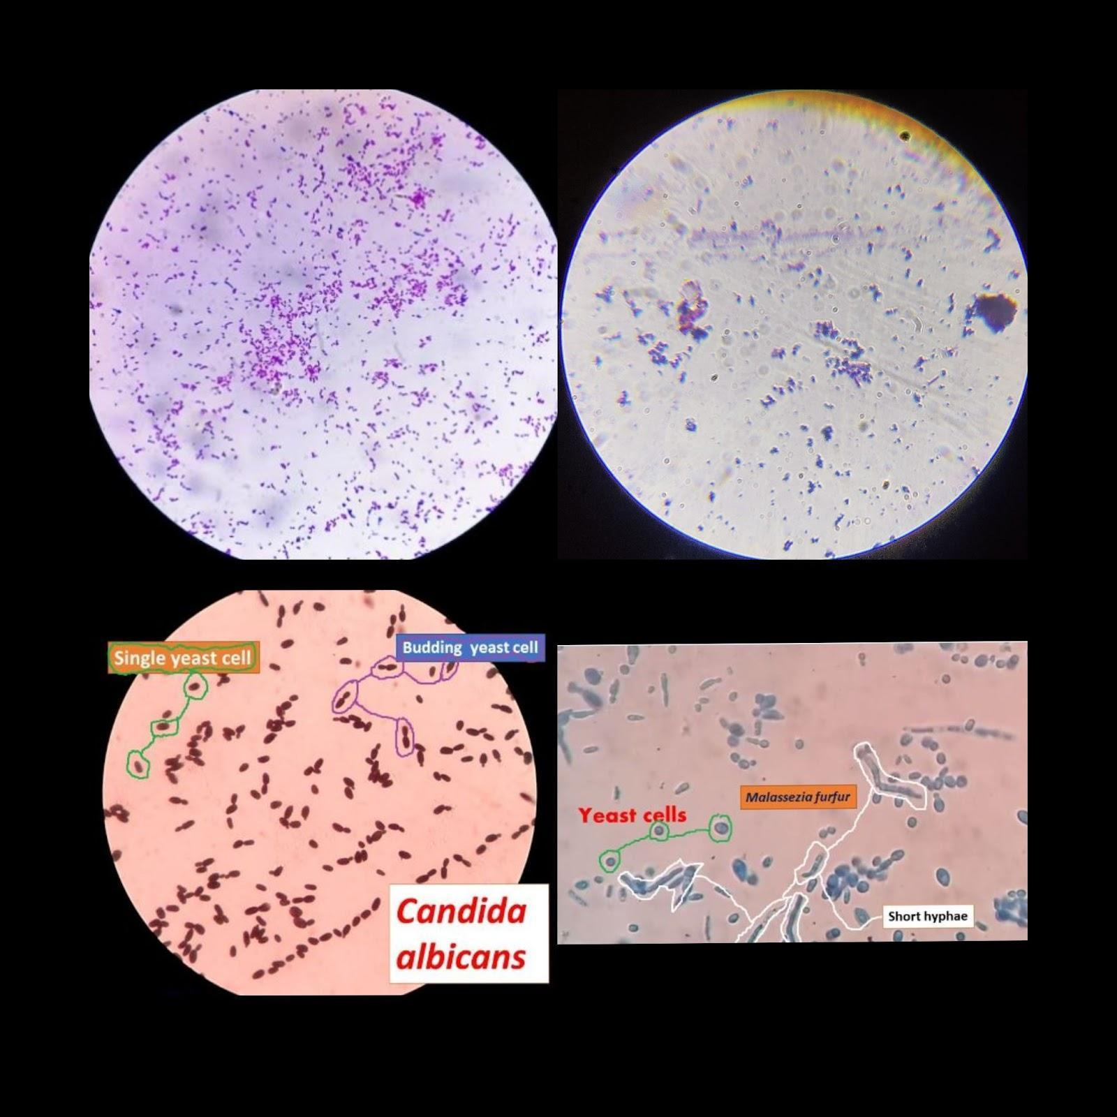
Fig S5: Characterization of Malessezia furfur

Table S1: Distinct Characters of M. furfur ^{[4,5]}
Information | Malessezia furfur
Description | Clusters of thick-walled round, budding yeast-like cells, and short angular hyphal forms.
Size | Between 1.5 and 4.5 × 2.0–6.5 micrometers.
Shape | Spherical-shaped and has a distinguishing bottleneck at one end.
Growth conditions | Human skin pH 5.5-5.6 as well as temperature 36°C-37°C with 24 hrs incubation time.

Results and discussion
Pre-Formulation Studies
- Extractive values –
Table S2: Extractive values
SR No | Name of Extract | Reading (gm) | Solvent Soluble Extract (%)
1 | Mexican Mint (water) | 0.13 | 5.2
2 | Mexican mint (ethanol) | 0.1 | 4

2) Antifungal bioassay Image-
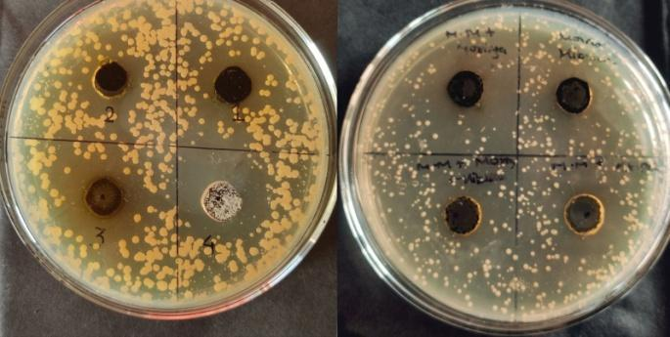
Fig S6: Individual and combined antifungal activity of test herbs

3) Absorption maxima (Lambda max)-
Following graphs were noted for extracts-

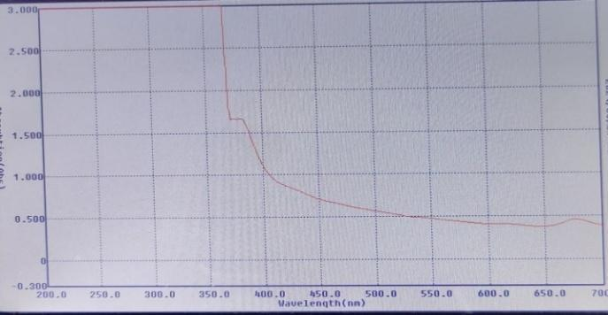
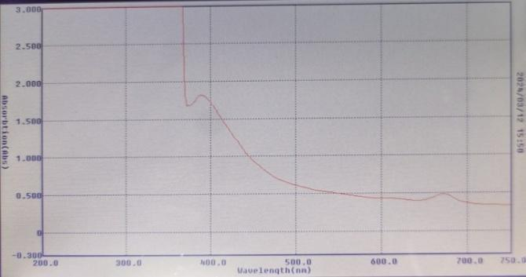
Fig S7: Absorption Maxima of Mexican Mint at pH 5.5 and pH 7.4 respectively

4] Standard curve for drug diffusion studies and quantitative tests-
- Drug Diffusion studies-

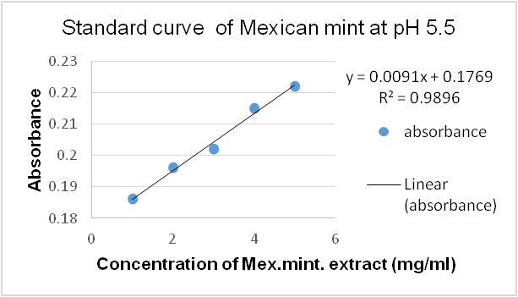
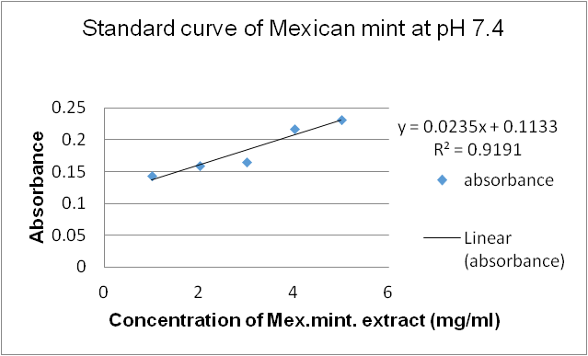
Fig S8: Standard Curve of Mexican Mint at pH 5.5 and 7.4

B. Phenolic content-
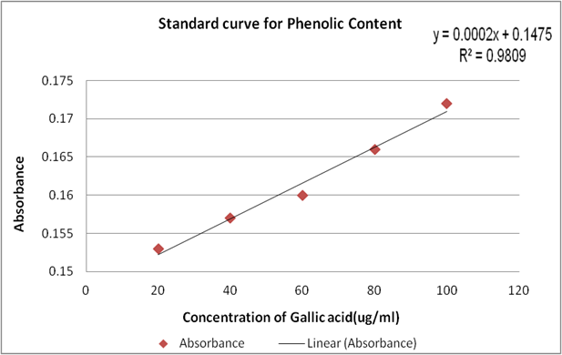
Fig S9: Standard Curve of Phenolic Content

C. Alkaloid content-

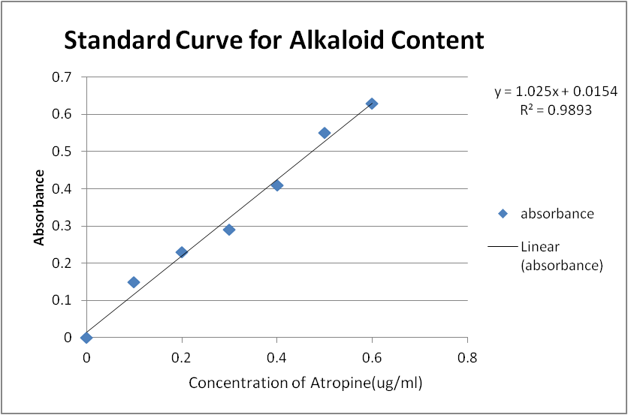
Fig S10: Standard Curve of Alkaloid content

5] TLC/Thin Layer Chromatography-

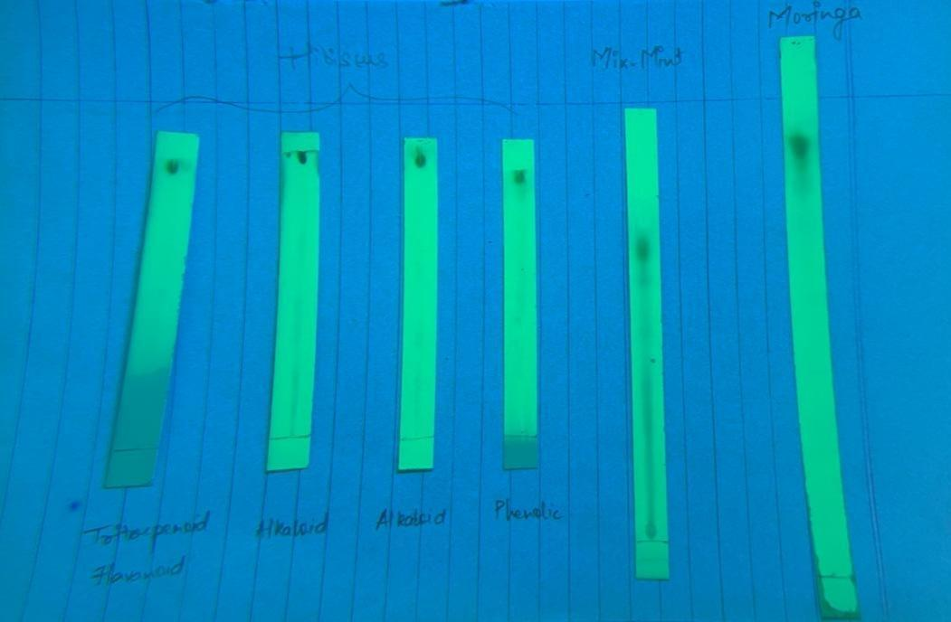
Fig S11: TLC of Mexican Mint

Table S3: TLC Calculation
SR. No | Detection of Chemical constituent in Extract | No of spots | Rf Value
1 | Mexican Mint | 2 | 0.82 ^{[6]}, 0.74 ^{[7]}

6] Chemical test (Qualitative analysis)-
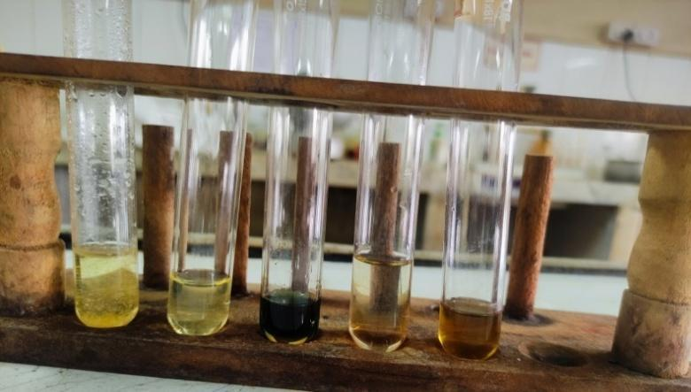
Fig S12: Chemical tests for Mexican mint

Table S4: Qualitative tests

Sr no | Chemical Constituent | Result
1 | Phenols | +
2 | Tannins | +
3 | Acetyl groups | +
4 | Terpenoids | +
5 | Triterpenoids | +

7] Quantitative analysis- Flavonoid content, Phenolic content and alkaloid content ^{[8]} –

Table S5: Quantitative tests

Name of extract | Phenolic content (mg of GAE /g of extract) | Alkaloid content (mg of AE/g of extract) | Flavonoid content (mg of QE/g of extract) ^{[8]}
Mexican mint | 78.37 | - | 7.532

8] Minimum Inhibitory Concentration (MIC) and Minimum Fungicidal Concentration (MFC)-

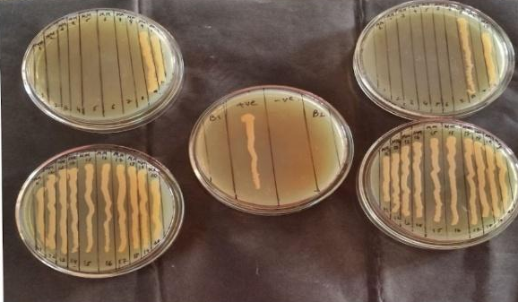
Fig S13: MFC of Mexican mint

Table S5: Quantitative tests
No | Species of fungi | Mexican Mint(mg/ml)
No | Species of fungi | MIC | MFC
1 | Malessezia furfur | 3.90 | 7.8

9) Anti-Inflammatory Assay-
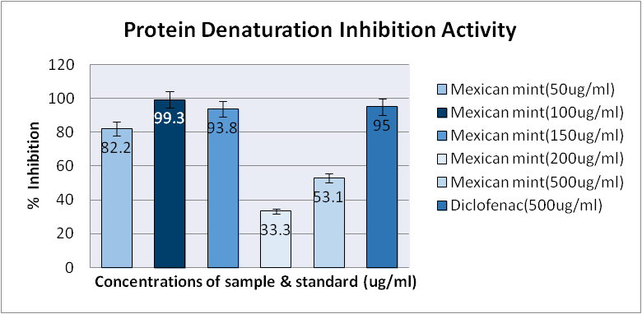
Fig S14: Anti-Inflammatory assay of Mexican mint

Post Formulation Studies
3) Viscosity-

Table S6: Viscosity Determination of Mexican Mint Hair Mask
SR. No | Spindle Speed | Factor | Dial Reading | Viscosity (c.p.s)
1 | 0.5 | 8000 | 63 | 5,04,000
2 | 1 | 4000 | 74 | 2,96,000
3 | 2 | 2000 | 88.5 | 1,77,000
4 | 2.5 | 1600 | 94.5 | 1,51,200

4] In vitro diffusion studies-

Table S7: Drug Diffusion studies of Mexican Mint Hair Mask
Sr No | Time (Hours) | % Drug Release at pH 5.5 | % Drug Release at pH 7.4
1 | 0 | 0 | 0
2 | 0.5 | 12.8 | 22.22
3 | 1 | 15.6 | 25.81
4 | 1.5 | 17.8 | 24.07
5 | 2 | 20.1 | 15.52
6 | 2.5 | 22.2 | 13.08
7 | 3 | 28.42 | 16.23
8 | 3.5 | 26.68 | 21.96
9 | 4 | 28.72 | 19.421
10 | 4.5 | 31.3 | 31
11 | 5 | 33.4 | 25.42
12 | 5.5 | 34.1 | 32.84
13 | 6 | 37.2 | 38.67

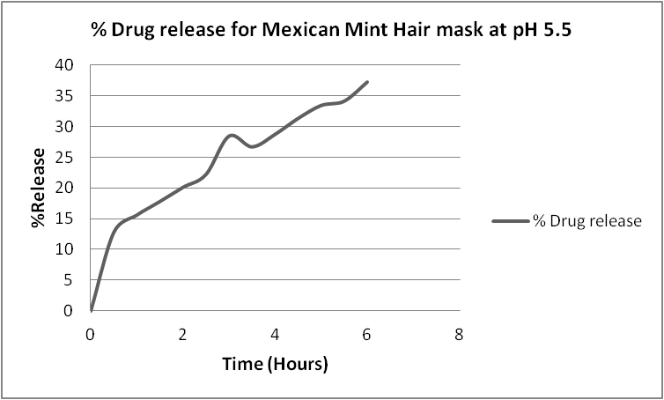
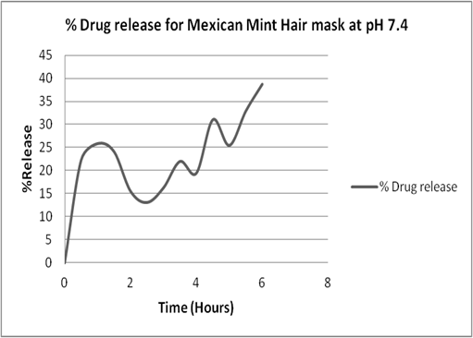
Fig S15: Diffusion Studies of Mexican Mint Hair mask at pH 5.5 and 7.4

5] Drug content-
Following results were obtained-
Table S8: Drug content of Hair Mask

Sr No | Hair Mask | Normal conditions | Stability conditions
1 | Mexican Mint | 97 | 96.9

6) Anti-fungal bioassay of product-
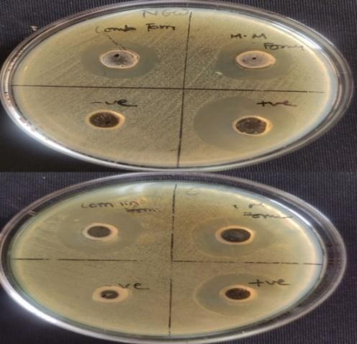
Fig S16: Antifungal bioassay of stability studies and original formulation

Table S9: Antifungal Bioassay of Product
Sr. No | Sample  Name | Temperature (⁰C)  (*Note - R1= Reading 1, R2 = Reading 2)
 |  | Stability Formulation (45⁰C) |  |  |  | Original Formulation (25⁰C)
 |  | R1 (ZOI in mm) | R2 (ZOI in mm) | A.I (R1) | A.I (R2) | R1 (ZOI in mm) | R2 (ZOI in mm) | A.I (R1) | A.I (R2)
1 | Mexican mint mask | 13 | 13 | 0.76 | 0.86 | 13 | 13 | 0.86 | 0.86
2 | Positive control (KTZ) | 17 | 15 | 1 | 1 | 15 | 15 | 1 | 1
3 | Negative control (Water) | 0 | 0 | 0 | 0 | 0 | 0 | 0 | 0

7] Stability studies-

Table S10: Stability studies of Hair mask ^{[9]}

Properties | Observation for Mexican mint Hair mask
pH (Initial, After one month) | 5.5, 7.1
% drug content (difference) | 0.1

References

- https://www.semanticscholar.org/paper/AN-OVERVIEW-OF-DANDRUFF-AND-NOVEL-FORMULATIONS-AS-A-Narshana-Ravikumar/333d12312a205b059d13dac5996a6f6063cd0bab/figure/4
- M. Narshana, P. Ravikumar, Dr. Bhanuben Nanavati. (2018). AN-OVERVIEW-OF-DANDRUFF-AND-NOVEL-FORMULATIONS-AS-A-Narshana-Ravikumar/333d12312a205b059d13dac5996a6f6063cd0bab/figure/2
- Figure 1. Basic steps in preparation of emulgel. (n.d.). Research Gate. https://www.researchgate.net/figure/Basic-steps-in-preparation-of-emulgel_fig1_355283653
- Dandruff. (2023). In Dandruff. Retrieved February 22, 2024, from https://en.wikipedia.org/wiki/Dandruff
- Malassezia Furfur. (2017). In Malassezia furfur. Retrieved February 22, 2024, from https://en.wikipedia.org/wiki/Malassezia_furfur
- Patel, R., Mahobia, N., Waseem, N., Upwar, N., & Singh, S. (2010). Phyto-Physicochemical Investigation of Leaves of Plectranthus amboinicus (Lour) Spreng. Pharmacognosy Journal, 2(13), 536–542.
- Alqarni, M. H., Foudah, A. I., Alam, A., Salkini, M. A., Alam, P., & Yusufoglu, H. S. (2021). Novel HPTLC-densitometric method for concurrent quantification of linalool and thymol in essential oils. Arabian Journal of Chemistry, 14(2), 102916. https://doi.org/10.1016/j.arabjc.2020.102916.
Thymol. (2022). In Indian Pharmacopoeia 2022 (Ninth, Vol. 3, p. 3786). Indian Pharmacopoeia Commission.
- Tambe, V. D., & Bhambar, R. S. (2014). RESEARCH AND REVIEWS: JOURNAL OF PHARMACOGNOSY AND PHYTOCHEMISTRY Estimation of total phenol, tannin, alkaloid and flavonoid in hibiscus tiliaceus Linn. wood extracts. Research & Reviews: Journal of Pharmacognosy and Phytochemistry, Volume 2.(Issue 4), e-ISSN:2321-6182 p-ISSN:2347-2332.
- Sawant, A. A., & Mohite, S. (n.d.). Formulation and Evaluation of Itraconazole Emulgel for Topical Drug Delivery. Asian Journal of Pharmacy and Technology, 5(2), 91. https://doi.org/10.5958/2231-5713.2015.00014.8

