Supplementary tables & figures

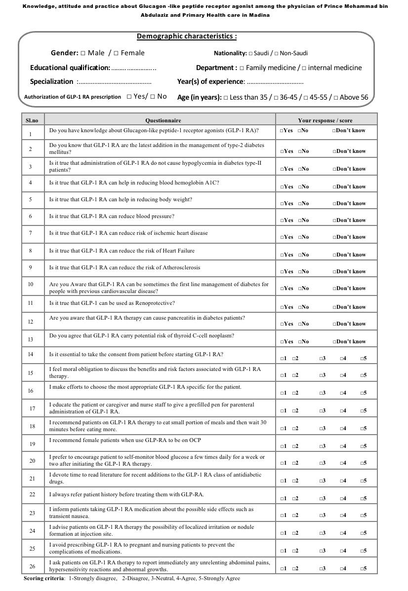
Supplementary figure 1:
Supplementary table 1:

Participants’ responses to knowledge items
Characteristic | No | Yes | Do not know
Do you have knowledge about Glucagon-like peptide1 receptor agonists (GLP-1 RA) | 3 (5.9%) | 46 (90.2%) | 2 (3.9%)
GLP-1 RA are the latest addition in management of type-2 diabetes mellitus | 3 (5.9%) | 40 (78.4%) | 8 (15.7%)
The administration of GLP- RA do not cause hypoglycemia in diabetes type-II patients | 12 (23.5%) | 32 (62.7%) | 7 (13.7%)
GLP-1 RA can help in reducing hemoglobin A1C | 0 (0.0%) | 51 (100.0%) | 0 (0.0%)
GLP-1 RA can help in reducing body weight | 2 (3.9%) | 47 (92.2%) | 2 (3.9%)
GLP- 1 RA can reduce the blood pressure | 13 (25.5%) | 19 (37.3%) | 19 (37.3%)
GLP-1RA can reduce risk of ischemic heart disease | 3 (5.9%) | 46 (90.2%) | 2 (3.9%)
GLP-1RA can reduce the risk of heart Failure | 4 (7.8%) | 39 (76.5%) | 8 (15.7%)
GLP-1 RA can reduce atherosclerosis | 3 (5.9%) | 40 (78.4%) | 8 (15.7%)
GLP-1 RA can be sometimes the first line management of diabetes for people with previous cardiovascular disease | 8 (15.7%) | 33 (64.7%) | 10 (19.6%)
GLP-1 RA can be used as a renoprotective | 8 (15.7%) | 35 (68.6%) | 8 (15.7%)
GLP-1 RA therapy can cause pancreatitis in diabetes patients | 3 (5.9%) | 46 (90.2%) | 2 (3.9%)
GLP-1 RA carries potential risk of thyroid C-cell neoplasm | 2 (3.9%) | 38 (74.5%) | 11 (21.6%)
n (%)

Supplementary table 2:

Participants’ responses to attitudes and practice items
Characteristic | Strongly disagree | Disagree | Neutral | Agree | Strongly agree
Attitude
Is it essential to take the consent from patient before starting GLP-1 RA | 6 (11.8%) | 8 (15.7%) | 9 (17.6%) | 6 (11.8%) | 22 (43.1%)
I feel moral obligation to discuss the benefits and risk factors associated with GLP-1 RA therapy | 5 (9.8%) | 3 (5.9%) | 5 (9.8%) | 11 (21.6%) | 27 (52.9%)
I make efforts to choose the most appropriate GLP-1 RA specific for the patient | 7 (13.7%) | 3 (5.9%) | 17 (33.3%) | 4 (7.8%) | 20 (39.2%)
I educate the patient or caregiver and nurse staff to give a prefilled pen for parenteral administration of GLP-1 RA | 6 (11.8%) | 2 (3.9%) | 15 (29.4%) | 7 (13.7%) | 21 (41.2%)
I recommend patients on GLP-1 RA therapy to eat small portion of meals and then wait 30 minutes before eating more | 4 (7.8%) | 7 (13.7%) | 23 (45.1%) | 5 (9.8%) | 12 (23.5%)
I prefer to encourage patient to self-monitor blood glucose a few times daily for a week or two after initiating the GLP-1 RA therapy | 6 (11.8%) | 9 (17.6%) | 13 (25.5%) | 7 (13.7%) | 16 (31.4%)
Practice
I recommend female patients when use GLP-RA to be on Oral Contraceptive | 3 (5.9%) | 9 (17.6%) | 24 (47.1%) | 6 (11.8%) | 9 (17.6%)
I devote time to read literature for recent additions to the GLP-1 RA class of antidiabetic drugs | 5 (9.8%) | 4 (7.8%) | 22 (43.1%) | 6 (11.8%) | 14 (27.5%)
I always refer patient history before treating them with GLP-RA | 6 (11.8%) | 0 (0.0%) | 10 (19.6%) | 9 (17.6%) | 26 (51.0%)
I inform patients taking GLP-1 RA medication about the possible side effects such as transient nausea | 4 (7.8%) | 6 (11.8%) | 3 (5.9%) | 6 (11.8%) | 32 (62.7%)
I advise patients on GLP-1 RA therapy the possibility of localized irritation or nodule formation at injection site | 6 (11.8%) | 5 (9.8%) | 11 (21.6%) | 16 (31.4%) | 13 (25.5%)
I avoid prescribing GLP-1 RA to pregnant and nursing patients to prevent the complications of medications | 2 (3.9%) | 4 (7.8%) | 24 (47.1%) | 4 (7.8%) | 17 (33.3%)
I ask patients on GLP-1 RA therapy to report immediately any unrelenting abdominal pains, hypersensitivity reactions and abnormal growths | 2 (3.9%) | 2 (3.9%) | 8 (15.7%) | 13 (25.5%) | 26 (51.0%)
n (%)

