Supplementary Data

Characterization of the modified clay:
XRD Analysis
The alkyl ammonium cation exchange enables the conversion of the hydrophilic interior nanoclay surface into the hydrophobic surface, which consequently increases the interlayer distance as well. Here NaMMT was modified with CTAB as intercalation agents through the cation exchange process. The cationic head groups of the intercalation agent molecule would preferentially reside at the layer surface and the aliphatic tail will radiate away from the surface. The presence of these aliphatic chains in the galleries makes the organically hydrophilic silicate modified to organophobic and thus increases the layer basal spacing of Na-MMT [1]. The organo modified CTAB-NaMMT was studied by using XRD (Fig. 1) in the 2θ range at a scanning rate of 2°/min. The basal spacing of NaMMT is 13.95 Å as calculated using the Bragg’s Equation:
2d sinθ = ƛ (1)
Where d is the basal spacing; θ is the Bragg peak angle; ƛ = 0.154 nm, the X-ray wavelength.

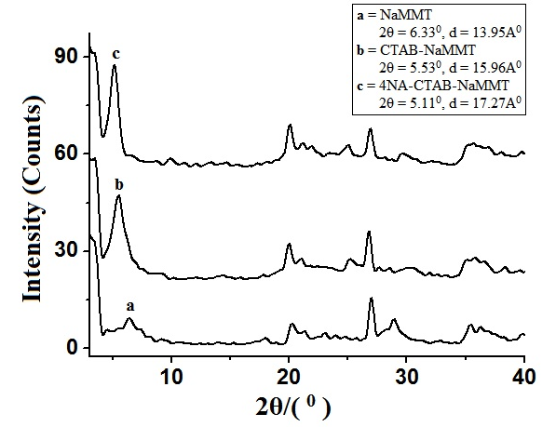

Fig.1: XRD of NaMMT and organomodified NaMMT

After the ionization reaction the basal spacing of CTAB-NaMMT increases from 13.95 to 15.96 Å, compared to that of NaMMT. Again, on intercalation with 4NA the basal spacing of 4NA-CTAB-NaMMT increased to 17.27 Å in comparison to 15.96 Å at CTAB-NaMMT.

FTIR Spectroscopy Analysis
Fourier transform infrared spectroscopy (FTIR) provides useful route to examine the presence of CTAB and 4NA functional groups in the clay (Fig. 2). The absorption bands at 1644 and 1482 cm^{–1} is ascribed to the –CH₃ group in CTAB. At the same time, the bands peak at 1644 cm^{–1} is also associated with the RN(CH₃)³⁺ ion in CTAB. Besides, the bands at 2850 cm^{–1} and 2930 cm^{–1} are caused by the stretching of –CH₂ group, which comes from CTAB with long aliphatic tail in their molecules [2]. Again, the band at 1590 cm⁻¹ attributed to the –NO₂ group of 4NA.

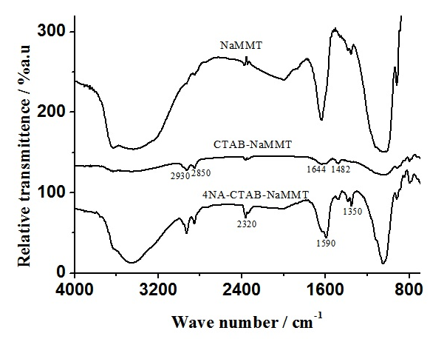

Fig.2: FTIR of NaMMT and organomodified NaMMT

Thermogravimetric analysis (TGA)
TGA of 4NA-CTAB-NaMMT was performed to study the thermal stability of the clay. At a given temperature the weight loss is directly related to the rate of the 4NA-CTAB-NaMMT decomposition process [3]. It is observed that the 4NA-CTAB-NaMMT differential thermal curve showed three parts, the free water region in the temperature below 210°C, the region where organic substance evolved between 210°C and 450°C, and the structural water region between 450°C and 800°C. The reason for the relatively low organic content for 4NA-CTAB-NaMMT is related to the dehydroxylation of the bonded OH group which can be detached during the purification.
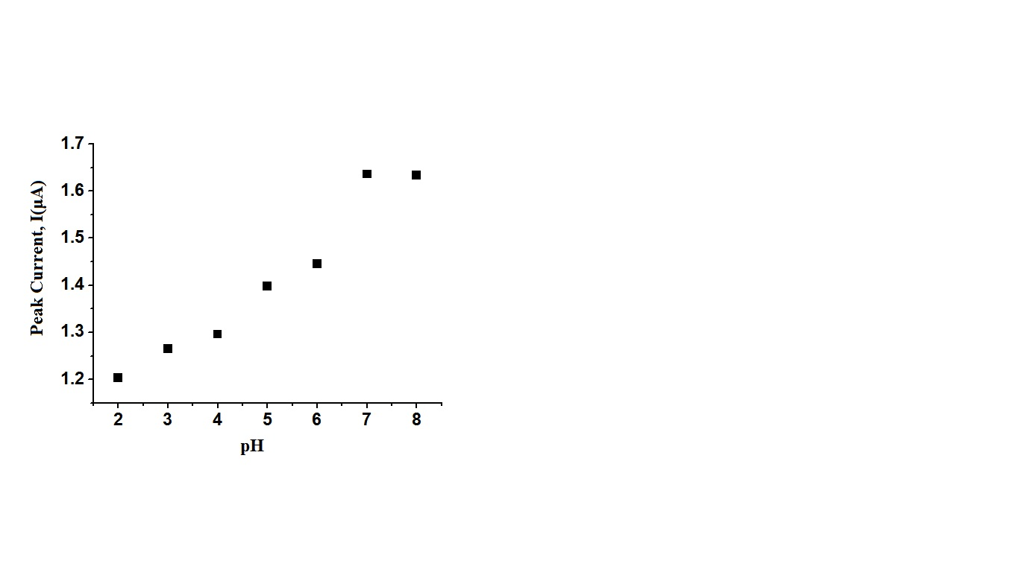
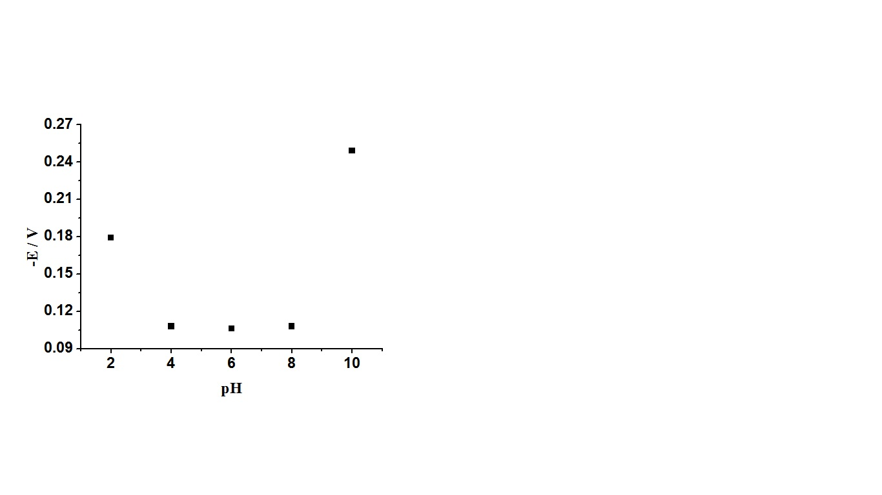
Effect of pH on the 4NACME:

Fig.3: Effect of pH on peak current of 4NACME in SWV technique. (Inset: effect of pH on peak potential of 4NACME in SWV technique)

Electrochemistry of DA, UA and AA at 4NACME:

Square wave voltammogram (SWV) of the 4NACME in PBS of pH 7.4 is demonstrated in Fig.4.
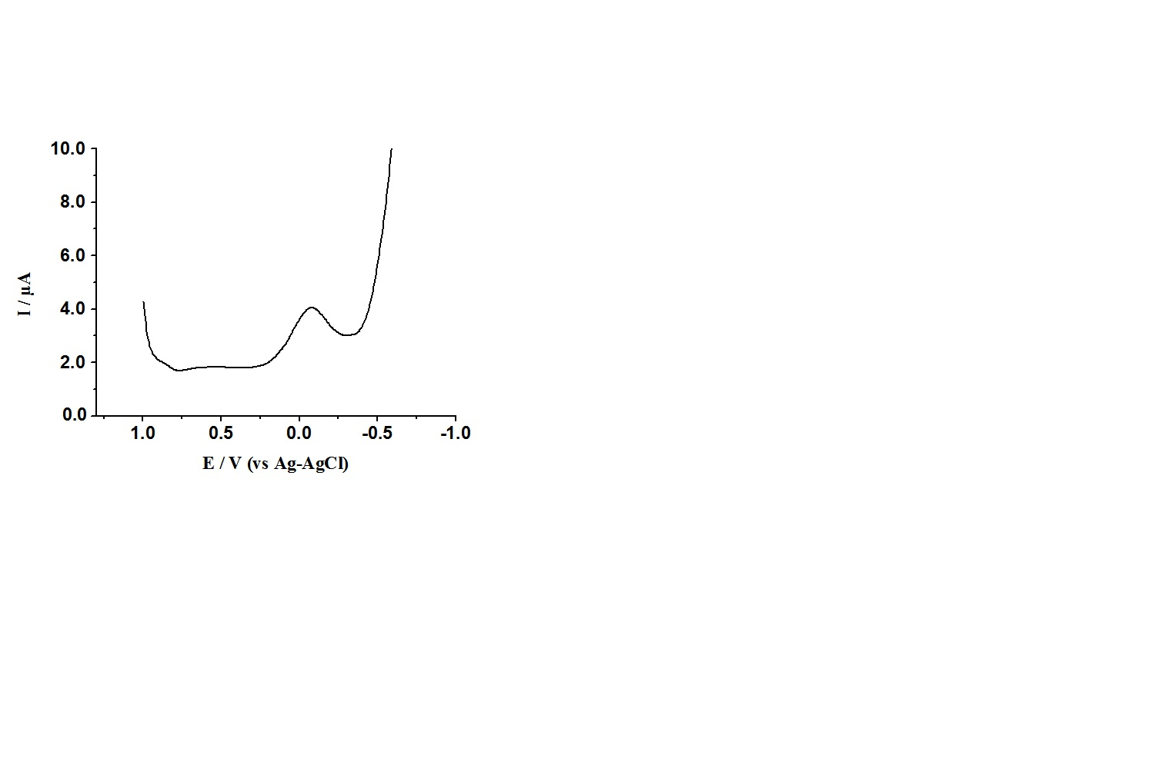
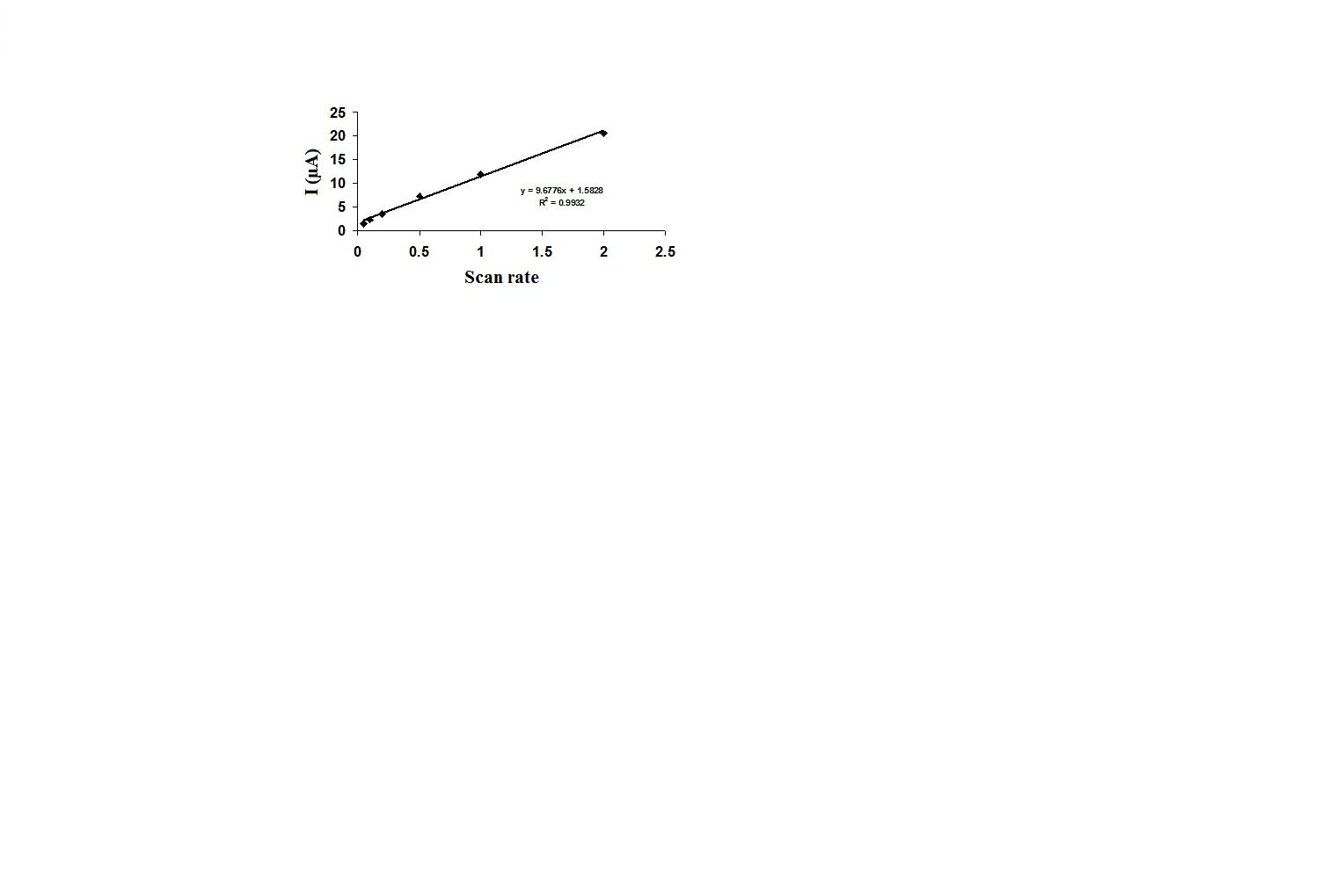

Fig.4: Square wave voltammogram of 4NACME in PBS of pH 7.4 (Ag-AgCl is the reference electrode, inset: plot of anodic current as a function of scan rate for 4NACME in PBS of pH 7.4 in cyclic voltammetric experiment)

A  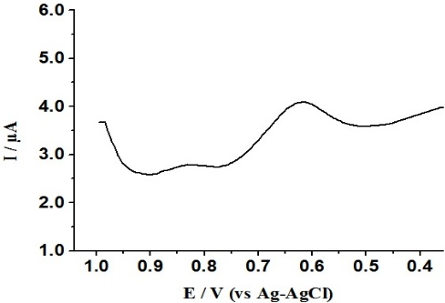 | 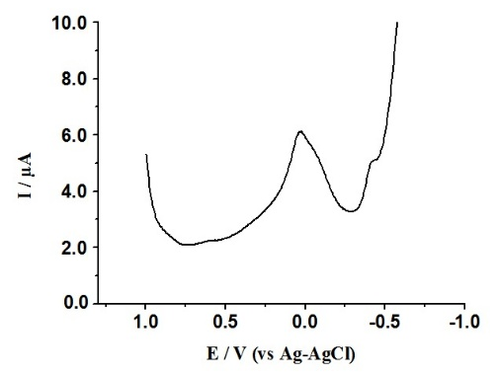  B | 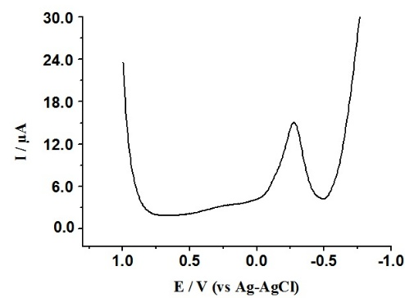  C

Fig.5: Square wave voltammogram of 4NACME in PBS of pH 7.4 containing 200nM DA (A), 360nM UA (B) and 960nM AA (C) (Ag-AgCl is the reference electrode)

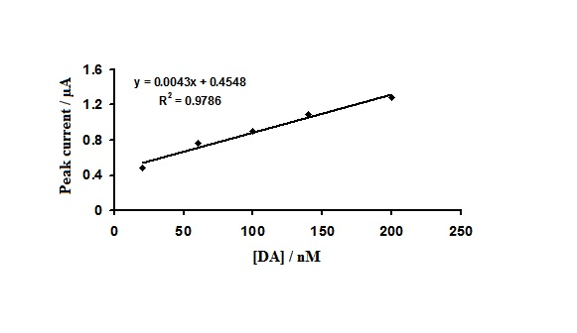  A | 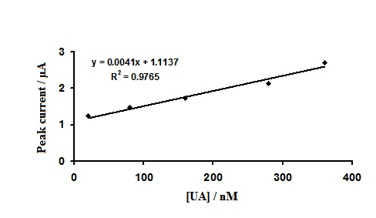  B | 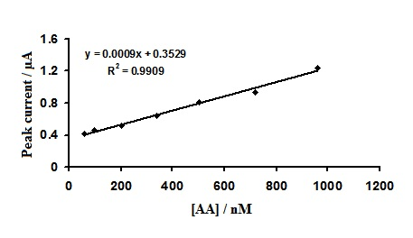  C

Fig.6: Effect of concentration of DA (A), UA (B) and AA (C) on the peak current of the 4NACME in PBS of pH 7.4 (Ag-AgCl is the reference electrode)

References
- Mansor B, Wisam H, Experimental Investigation on Geomechanical Properties of Tropical Organic Soils, Journal of Engineering and Applied Sciences. 2009; 4:184–188. https://www.researchgate.net/publication/26624651_Experimental_Investigation_on_Geomechanical_Properties_of_Tropical_Organic_Soils_and_Peat
- Hoidy W, Ahmad M, Mulla A, Ibrahim NA, Synthesis and Characterization of Organoclay from Sodium Montmorillonite and Fatty Hydroxamic Acids, American Journal of Applied Science. 2009; 6:1567–1572. http://dx.doi.org/10.3844/ajassp.2009.1567.1572
- Beall GW, ​The Use of Organo-Clays in Water Treatment, Applied Clay Science. 2003; 24:11–20. https://doi.org/10.1016/j.clay.2003.07.006

